STIX Application Page Flow Diagram

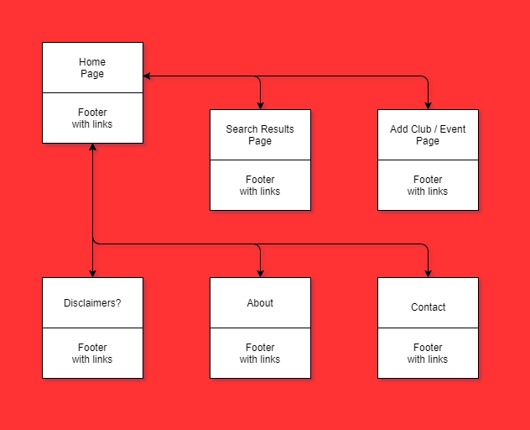

All pages will have a clickable logo at the top that links to the home page, so technically all pages should link to the home page.

The home page will lead to 2 pages – the search results and the “Add” content pages.

All pages will have a footer, hence the arrows leading to and from the footer area.

From the footer 3 pages can be accessed: Disclaimers(?), About, and Contact.